HAProxy Load Balancer – Failover Mechanism

Overview
This document describes the automatic failover mechanism implemented using HAProxy to route traffic between a hot (primary) and a standby (backup) backend cluster.
- Failover and recovery are fully automatic
- No manual intervention or application changes required
- Decisions are based on HTTP health checks

HAProxy Configuration

backend backend_pool
option httpchk GET /healthz
http-check expect status 200

server hot <HOT_IP>:80 check inter 1s fall 2 rise 1
server standby <STANDBY_IP>:80 check inter 1s fall 2 rise 1 backup
#backup keyword defines back up for the cluster

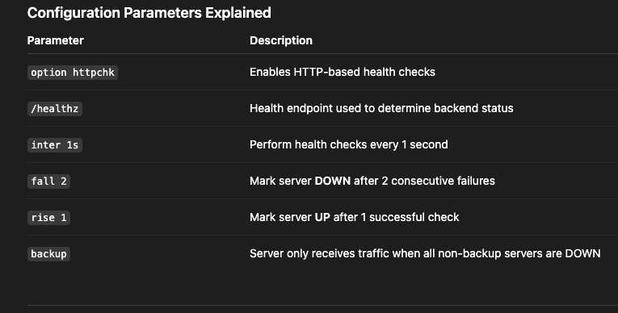

Traffic Flow & Failover Logic

Normal Operation
- Incoming request reaches HAProxy
- HAProxy checks primary (hot) server health
- If primary is UP, traffic is routed to the hot cluster
- Standby remains idle

Failover Scenario
- Primary fails health checks (2 consecutive failures)
- Primary marked DOWN
- Traffic automatically routed to standby backend
- Failover time: ~2 seconds
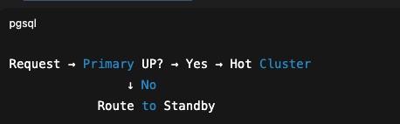

Recovery Flow
- Primary passes a health check
- Primary marked UP
- Next incoming request automatically routed back to primary
- Recovery time: ~1 second



Validation / Testing

Test Failover
kubectl scale deployment backend-service -n hot --replicas=0

Test Recovery
kubectl scale deployment backend-service -n hot --replicas=2

Key Benefits
- Fully automatic – Built-in HAProxy health checks
- Fast failover – ~2 seconds
- Fast recovery – ~1 second
- Primary/Backup model – Backup used only when needed
- Health-based routing – Uses HTTP response validation, not just TCP reachability

Key References
https://www.haproxy.org/
https://en.wikipedia.org/wiki/HAProxy
https://www.youtube.com/watch?v=9GWziEBoDqQ

